**DAILY ONLINE ACTIVITIES SUMMARY**

|  |  |  |  |  |
| --- | --- | --- | --- | --- |
| **Date:** | 09/07/2020 | **Name:** | JASLINE SHARON TAURO | |
| **Sem & Sec** | 4th sem,  A Section | **USN:** | 4AL18CS029 | |
| **Online Test Summary** | | | | |
| **Subject** | N/A | | | |
| **Max. Marks** | N/A | **Score** | N/A | |
| **Certification Course Summary** | | | | |
| **Course** | INTRODUCTION TO HTML5 | | | |
| **Certificate Provider** | Coursera | **Duration:** | | 3 hrs |
| **Coding Challenges** | | | | |
| **Problem Statement:**  Write a java program to find the sum of multiple numbers using Method Overloading. | | | | |
| **Status:** | | Executed | | |
| **Uploaded the report in GitHub** | | YES | | |
| **If yes Repository name** | | <https://github.com/jaslinesharontauro/JAVA_Prgms> | | |
| **Uploaded the report in slack** | | YES | | |

**Certification Course Details:**

Today I started the new course “INTRODUCTION TO HTML5” by Coursera. Today I learnt about Introduction of HTML, Its evolution, its tools and its working. I have completed week1 portion of this course.

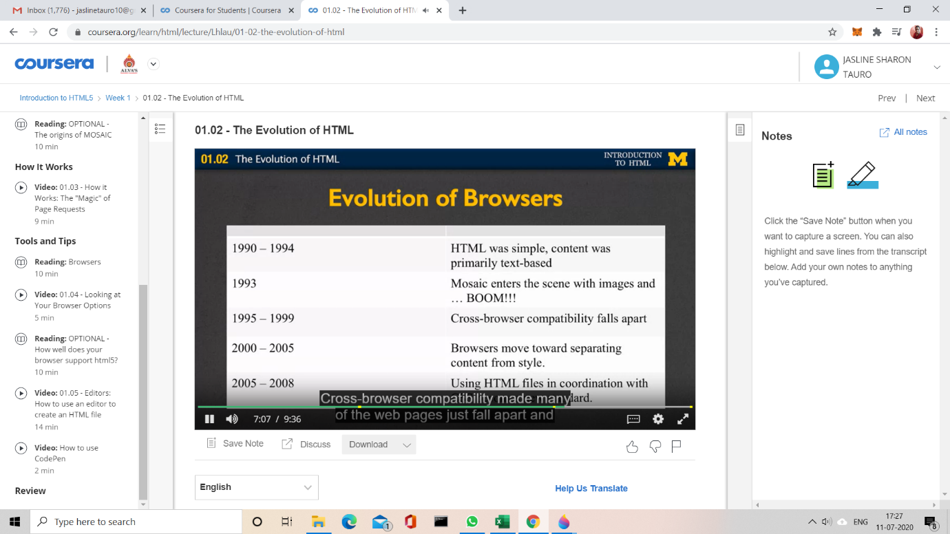

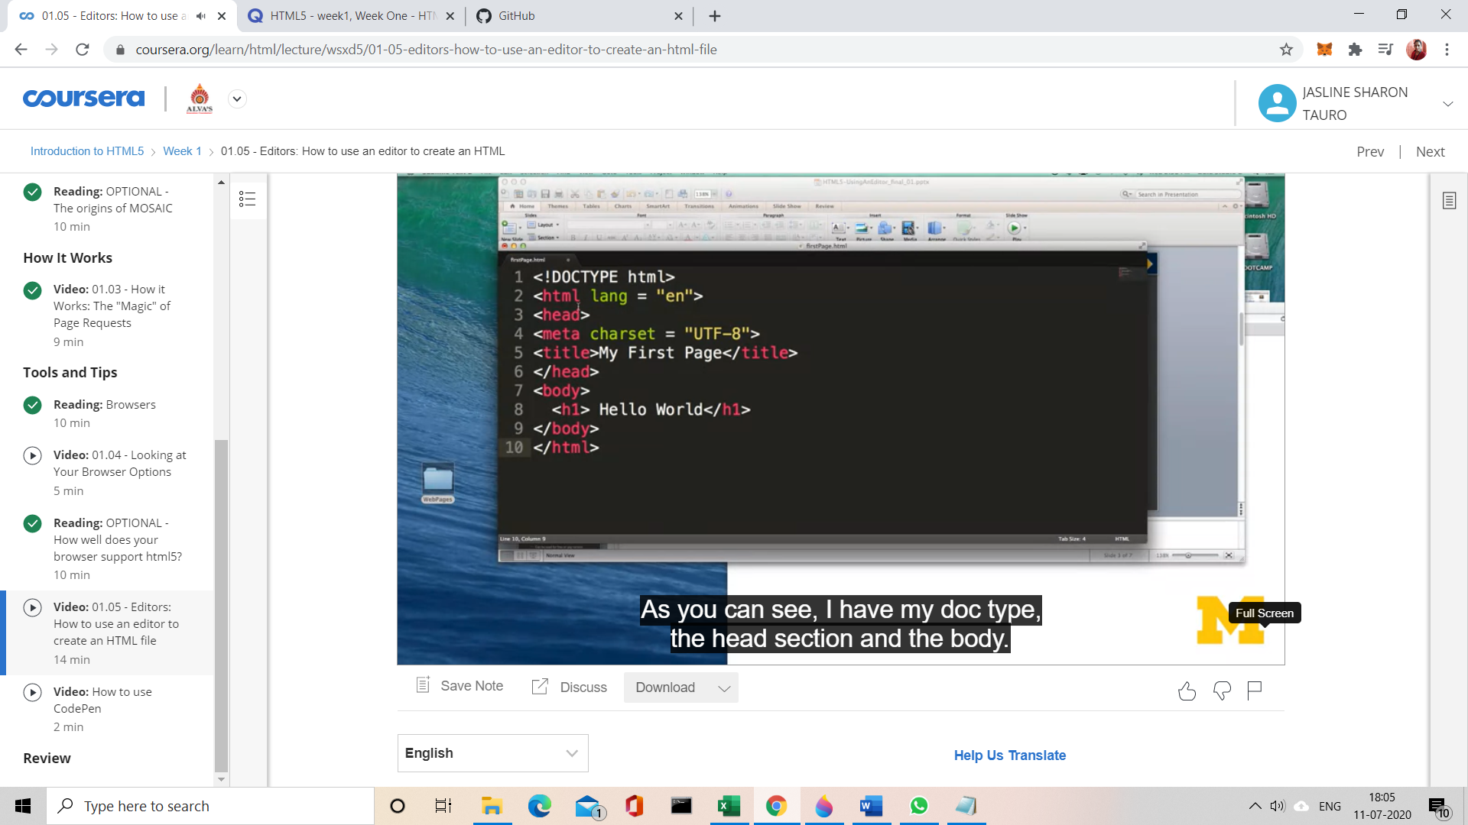

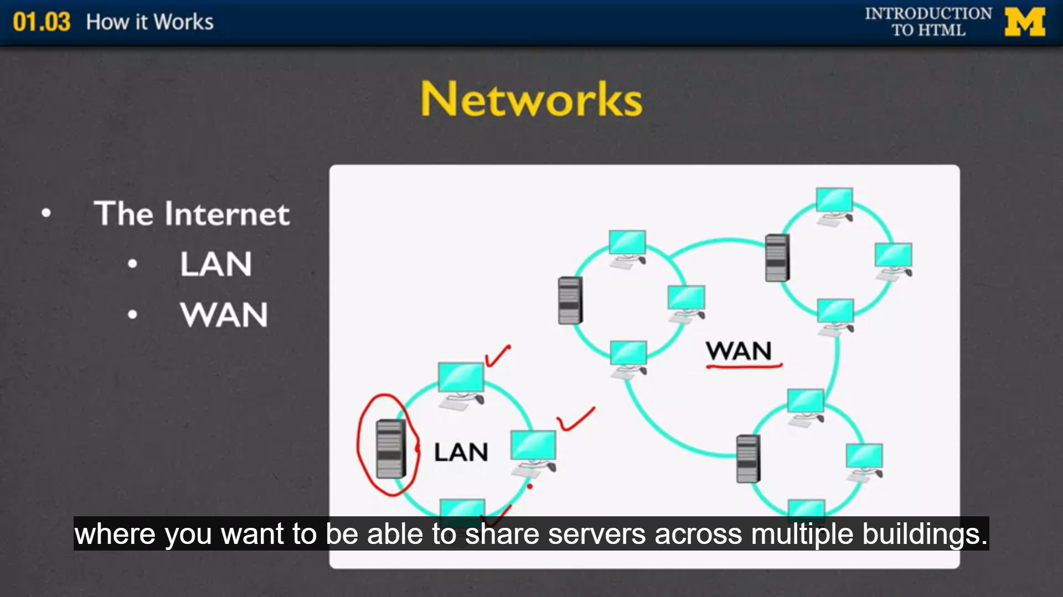

WBINAR DEDATILS:

Today we had a webinar on “Programming in C++”by Assistant professor MS. Shruthi Shetty J -AIET. The session included the topics of Inheritance and Polymorphism.

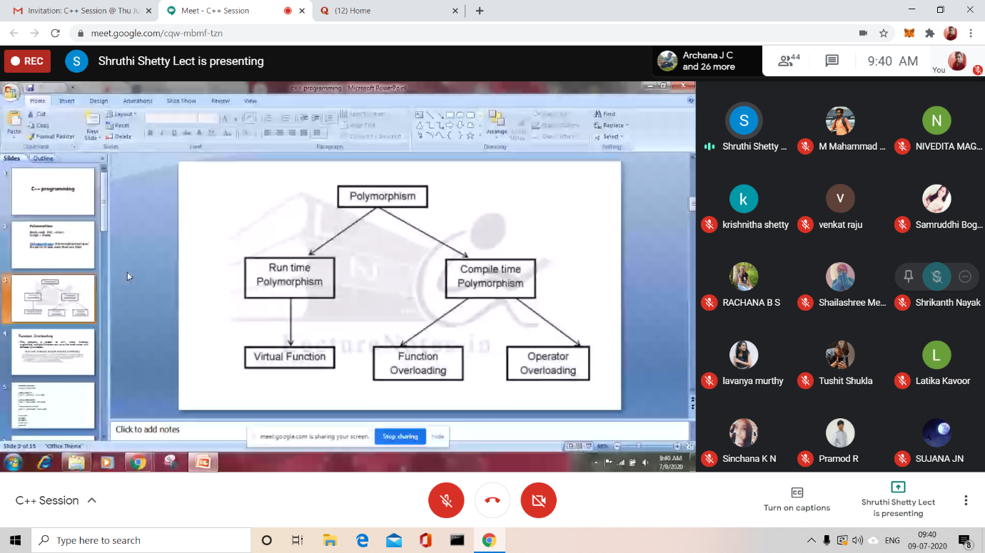

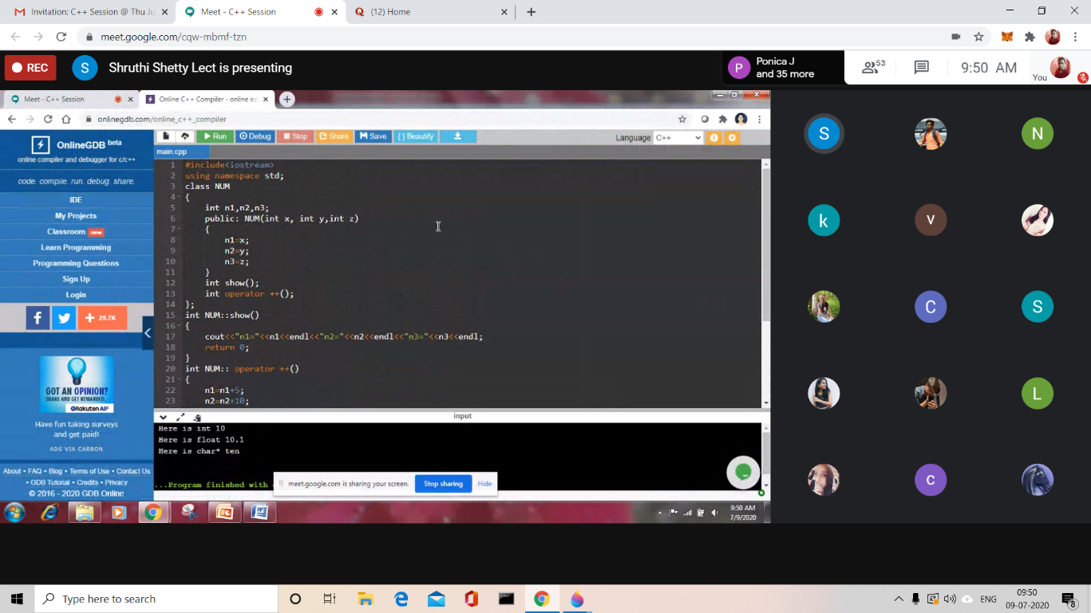

CODING CHALLENGES:

Problem Statement:

## Write a java program to find the sum of multiple numbers using Method Overloading.

Explanation:

First add () method has two arguments which means when we pass two numbers while calling add () method then this method would be invoked. Similarly, when we pass three and four arguments, the second and third add method would be invoked respectively.

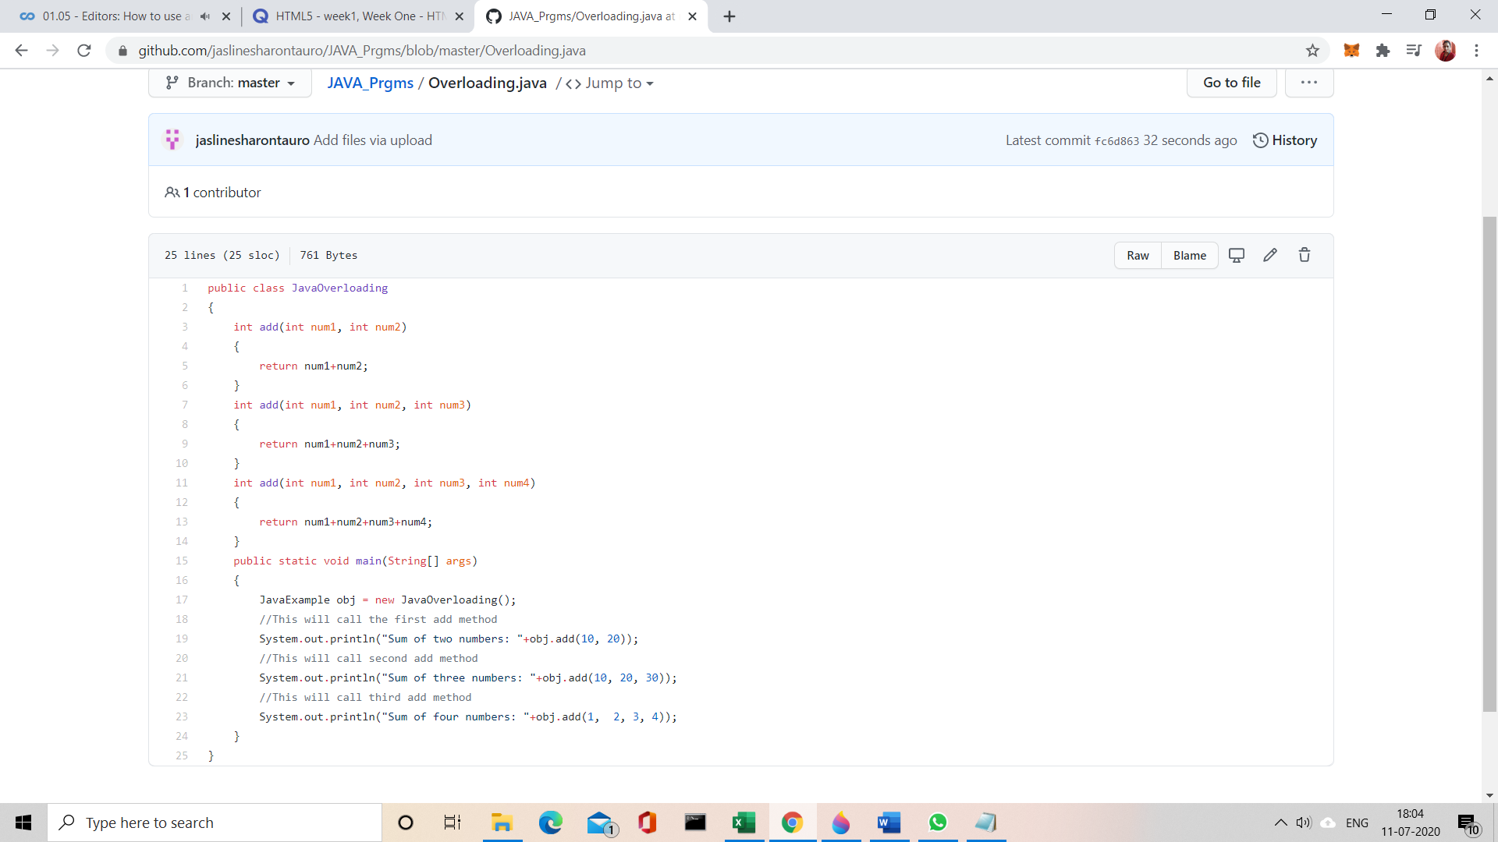

Solution uploaded in GitHub